EXECUTIVE SUMMARY

RESETTLEMENT ACTION PLAN

For

Ampati pora Purakhasia Road (AP) do·a improvement, 20th km pora 28th km
bilsi, Meghalaya Logistics and Connectivity Improvement Project (MLCIP)
rang·san, World Bank fund ka·se.

Submitted To

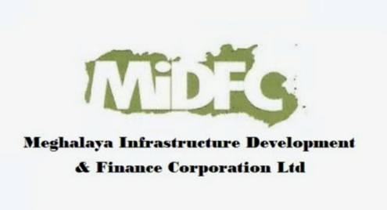

Meghalaya Infrastructure Development Finance Corporation (MIDFC) Ltd.
House No. L/A-56, Lower Nongrim Hills, Top Floor,
Meghalaya Basin Development Authority (MBDA) Building,
Shillong East Khasi Hills, Meghalaya-793003

EXECUTIVE SUMMARY

1. Project Background

Ampati–Purakhasia Road (Chainage 20+000 to 28+000, total length 8.0 km) do·a improvement ka·a kam, Meghalaya Logistics and Connectivity Improvement Project (MLCIP) ning baksa ong·a kam ong·a, World Bank fund ka·a aro Meghalaya Public Works Department (MPWD) rang·san implement ka·a. Project ia South West Garo Hills District, Meghalaya-o dong·a. Ia kam-ni regional connectivity rang·san improve ka·a, travel time kom ka·a, market aro services-na sokna rang·san access ka·a aro tribal area-rang socio-economic development-ko support ka·a miksong ong·a.

2. Need for the Resettlement Action Plan

Resettlement Action Plan (RAP) ko tayari ka·a, existing 12 m Right of Way (ROW) ning gitalo proposed road improvement kam-na ong·a social impact-rang-ko handle ka·na gita. RAP-ni World Bank Environmental and Social Standards (ESS5 aro ESS7), national law aro jylla policy-rang baksa comply ka·a, aro impact mitigation, compensation, livelihood restoration aro indigenous community-rang-ko protect ka·na framework ko on·a.

3. Project Impacts and Affected Population

Project-ni minor aro localized impact-rang ong·a, main-ta structure aro asset-rang-ko partial impact ong·a. Total 5 Project Affected Households (PAHs), jekon 20 Project Affected Persons (PAPs) ong·a, identify ka·a. Land acquisition dong·ja, physical displacement dong·ja aro involuntary resettlement dong·ja. Affected household-rang pilakan Scheduled Tribe (Garo) community-ni ong·a.

4. Socio-Economic Profile

PAH-rang pilakan Garo Scheduled Tribe-ni ong·a, je project area-ni tribal character-ko dakchaka. Livelihood-rang mainly small private business aro agriculture-na depend ka·a, income diversification kom ong·a. Mitam household-rang-o bu·rang (elderly) member-rang dong·a, je vulnerability-ko dakchaka. Women-rang PAP-rang ning badingo bakra ong·a aro gender-inclusive measure-rang livelihood aro employment opportunity-rang-o integrate ka·a..

5. Consultation, Disclosure, and FPIC

Structured stakeholder engagement process follow ka·a, jeni gitalo multiple consultation round aro Free, Prior and Informed Consent (FPIC) meeting 4 round September–December 2025 bilsi conduct ka·a. Consultation-rang PAPs, Nokma-rang, village council-rang, women, bu·rang aro sorkar official-rang baksa ong·a. Project information, impact, entitlement aro grievance mechanism-rang local language-o disclose ka·a aro signed Minutes of Meeting (MoM) bilsi community consent document ka·a.

6. Eligibility and Entitlements

Eligibility-ni non-titleholder jara usufruct right dong·a, tenant-rang aro Nokma rang·san represent ka·a community institution-rang baksa cover ka·a. Entitlement-rang affected structure replacement cost-o compensation, livelihood assistance, applicable ong·aode transitional support aro community asset restoration ong·a. Entitlement framework RFCTLARR Act, 2013, MPWD Resettlement Policy Framework aro World Bank ESS5 baksa aligned ong·a.

7. Institutional Arrangement aro Grievance Redress

MPWD-ni overall RAP implementation-ko responsibility ong·a, dedicated RAP Implementing Agency rang·san support ka·a. Multi-tier Grievance Redress Mechanism (GRM) community aro project level-o establish ka·a, jeni PAP-rang aro local institution-rang represent ka·a, je grievance-rang timely aro transparent resolution-ko ensure ka·a.

8. Implementation Schedule aro Budget

RAP implementation civil work start ka·na skang complete ka·na plan ka·a. RAP-o dedicated Resettlement and Rehabilitation (R&R) budget provide ka·a, jeni compensation, assistance, livelihood restoration, consultation aro administrative cost-rang cover ka·a.

9. Monitoring aro Evaluation

Internal monitoring MPWD rang·san conduct ka·a aro consultant-rang support ka·a, jeni compensation disbursement, livelihood restoration, FPIC commitment aro grievance resolution-rang-ko track ka·a. Monitoring indicator aro reporting mechanism-rang RAP-o clearly define ka·a.

10. Grievance Redress Mechanism (GRM)

Ka·ding flowchart-o two-tier grievance redressal mechanism-ko dakchaka, responsibility aro resolution timeline-rang baksa.

Tier I: Project Site Level | Responsibility: Village Executive Committee (VEC) aro Headman  Timeline: 15 sngi bilsi resolution  Unresolved ong·ode → PMU (Tier–II)-o escalate ka·a
Tier II: State Level (PMU) | Responsibility: Secretary (Planning), Chief Engineer, Project Director, Social Expert  Timeline: 15 sngi bilsi resolution

Grievance Redressal Mechanism
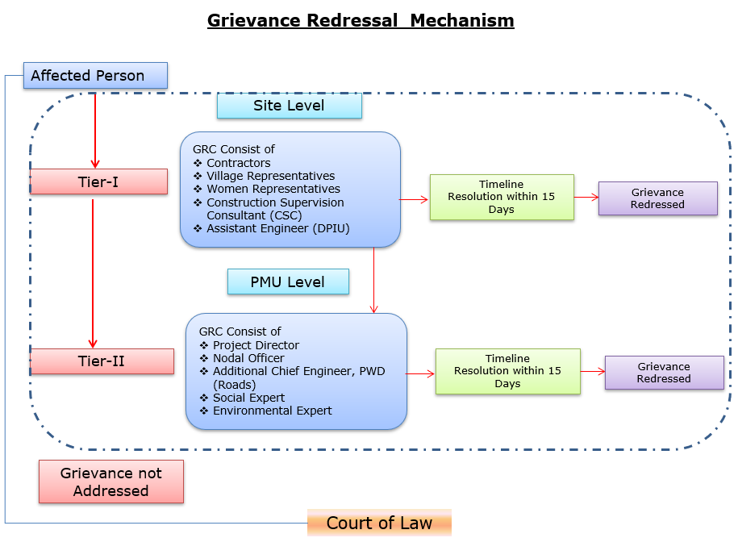

Grievance-rang-ni Contact Details
Description | Contact details
Company: | PWD, Meghalaya
To: | Chief Engineer-cum-Nodal officer
Address: | HV9P+GFJ, Lachumiere, Shillong, Meghalaya 793001
E-mail: | esmlcip@gmail.com
Website: | http://megpwd.gov.in/contacts.html
Telephone: | Tel: 0364-3572466
Fax: | -

11. Conclusion
Ampati pora Purakhasia Road (AP) ni Resettlement Action Plan (RAP) project-ni inclusive development, tribal rights ni protection, aro social sustainability-ni strong commitment-ko dak mesok ka·a. Project-o resettlement impact chhonbat chhonbat ong·a, community engagement bata ong·e strong ong·a aro mitigation measures proper ong·a implement ka·na man·a. Iani sab rang·san project-o socio-economic benefit-rang community-rang-na bata ong·e help ka·na man·a aro affected person-rang-ko fair aro equitable tarike-o treat ka·na ong·a.

